**Scanner Test**

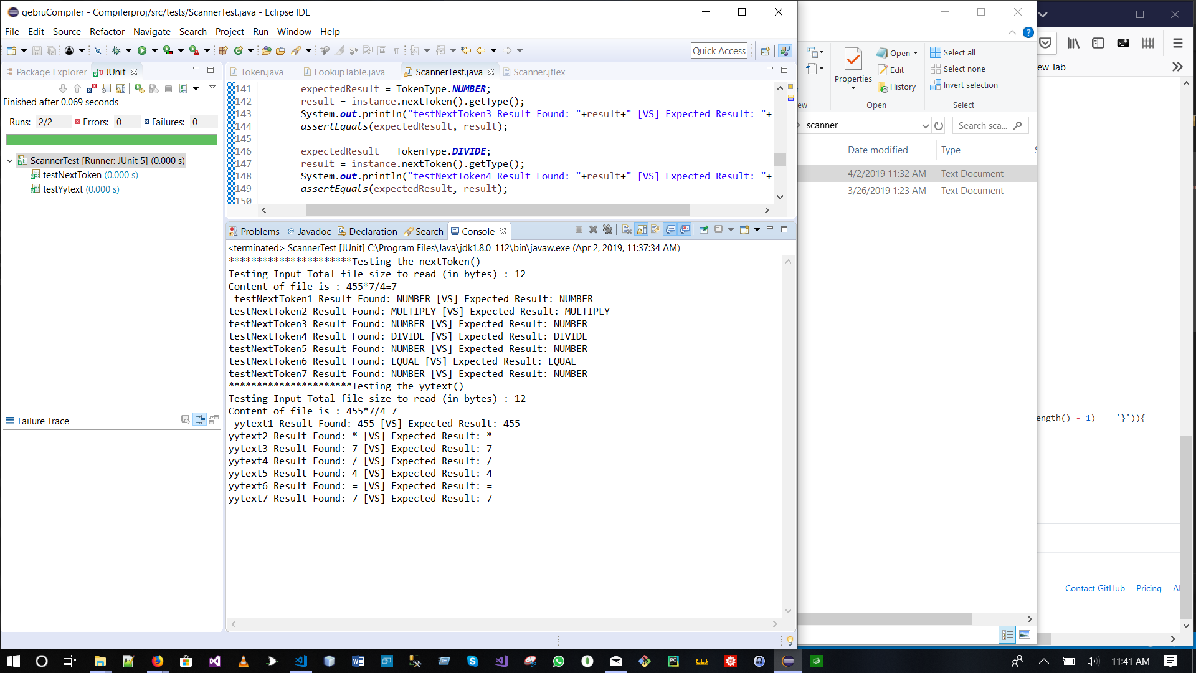

**Parser Test**